Michael Wierenga
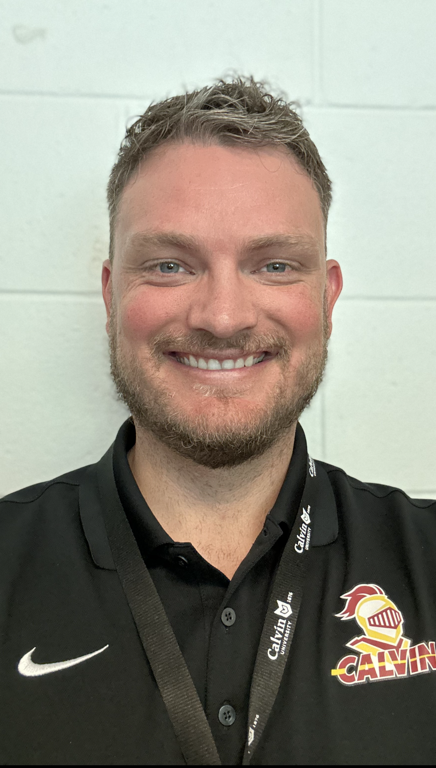
3858 Pfeiffer Woods Ct.
Kentwood, MI 49512

(616) 914-6599
mjw35@calvin.edu

Education
Michigan State University – East Lansing, MI
Ph.D.: Exercise Physiology – Department of Kinesiology - completed April 2023
Cumulative GPA: 3.8/4.0
Graduate Teaching Assistant – Tennis I, Applied Anatomy , The Healthy Lifestyle, Exercise Physiology Lab, Cadaver Anatomy Lab
Relevant Coursework: Introduction to Epidemiology, Cardiovascular Epidemiology, Causal Inference Epidemiology, Physical Activity and Well-being, Psychosocial Aspects of Sports and Physical Activity, Metabolic Responses to Exercise, Life course Physiology, Sport Psychology for Young Athletes

Central Michigan University - Mt. Pleasant, MI
M.A. Master of Arts: Exercise Physiology – completed May 2017
Cumulative GPA: 3.78/4.0
Graduate Teaching Assistant – see Relevant Work Experience below
Relevant Coursework: Physiology of Sport and Exercise, Motor Learning and Human Performance, Cardiovascular Exercise Physiology, Biostatistics, Research Methods, Advanced Clinical Exercise Physiology

Calvin College - Grand Rapids, MI
B.A. Bachelor of Arts – completed Spring 2015
Major: Kinesiology/Exercise Science
Cumulative GPA: 3.606/4.0
Dean’s List Honoree 2011-2014
Faculty Honor Scholarship recipient 2011-2014
Heart & Hand Scholarship recipient 2011
Relevant Coursework: Strength and Conditioning, First Aid and Emergency Care, Nutrition, Anatomical Kinesiology, Biomechanics, Exercise Physiology, Human Physiology, Advanced Practices in Exercise Science, Psychology of Sport and Exercise, Cardio Respiratory Fitness, Muscular Fitness, Cell Biology and Genetics, Human Anatomy, Developmental Psychology, General Chemistry, Physics I, Probability and Statistics

Relevant work Experience
Affiliate Faculty in the Department of Kinesiology: Calvin University, Grand Rapids, MI (Fall 2021-Present)
In my role as affiliate faculty at Calvin University, I have taken on a variety of responsibilities. The first is teaching both undergraduate and graduate classes. Since fall of 2021 I have taught 14 different Kinesiology and Health classes (KIN 204, KIN 213, KIN 214, KIN 216, KIN 223, KIN 500, HE 203, HE 308, HE 254, HE 265, HE 266, PER 106, PER 132, and PER 174). My responsibilities as instructor of these classes include development of class material, teaching classes and labs, grading course materials, interacting with students, and cultivating an environment conducive to Christian learning. I have taught classes in-person and online.

I also am an advisor at Calvin for twenty-five undergraduate Kinesiology majors. This role includes meeting and communicating with students periodically to assist them in choosing classes that satisfy university and major requirements as well as pique their interest in subjects that may be applicable to their future careers.

I am an active member of the faculty and regularly attend faculty meetings. I am also part of two committees in the School of Health Sciences (SOH Marketing Task Force, IPE Committee)

Graduate Research Assistant: Michigan State University, East Lansing, MI (Fall 2020-Spring 2021)
I am currently working on a physical activity intervention in East Lansing and surrounding area schools. This intervention is called the Sanford Fit4 Schools Intervention. The purpose of this project is to test the effectiveness and feasibility of Sanford Fit’s to increase physical activity in school aged children.

Graduate Teaching Assistant: Michigan State University, East Lansing, MI (Fall 2017-Spring 2020)
I worked as a graduate teaching assistant in the anatomy/cadaver lab and exercise physiology lab. I have also been an instructor for Intro to Tennis, and Healthy Lifestyles courses. My responsibilities include teaching lab and lecture material, supervising all lab activities, communication with students, and grading of all course materials.

Graduate Teaching Assistant: Central Michigan University, Mt. Pleasant, MI (Fall 2015-Spring 2017)
I assisted with teaching labs and lectures for ECG Assessment and Exercise Conditioning and Health Fitness classes. My responsibilities included introducing new topics, supervising all lab activities, monitoring students’ basic lab techniques, answering questions, and grading assignments, quizzes, and lab reports.

Lab Assistant: Calvin College, Grand Rapids, MI (Spring 2015) I volunteered as a lab assistant for Exercise Physiology classes at Calvin College under the supervision of Dr. Julie Walton. Responsibilities included monitoring students’ basic lab techniques, answering questions, and mastering my own skills in the Exercise Physiology lab.
Student Trainer: Calvin College, Grand Rapids, MI (Fall 2014) As part of an advanced practices exercise science course, I trained a volunteer from Calvin College’s administration for an entire semester. My client had a history of pulmonary embolism, as well as Type II diabetes. I gained valuable experience in various methods of exercise program planning, testing methods and training.

Publications
- Perkins, Jan, Wierenga, Michael, Saltarelli, William, Moncada-Sullivan, Miranda. "Pedometer Step Counts and Metabolic Syndrome Risk Factors in Middle School Students in Rural Michigan." Journal of Physical Activity Research, vol. 2, no. 1, 22 May 2017.
- Wierenga, Michael, Clevenger, Kimberly A., Pfeiffer, Karin A., “Three-Year Tracking of Moderate-to-Vigorous Physical Activity During Structured and Unstructured Play In Youth.” 2179 Board #15, May 2018 Medicine & Science in Sports & Exercise 50:528, DOI:
10.1249/01.mss.0000536826.56813.44, Conference: ACSM
- Wierenga, Michael, Clevenger, Kimberly A., Pfeiffer, Karin A., “Evidence for Compensation or Synergy Children's Activity During Outdoor and Indoor Preschool Time”: 1921 Board #77 May 30 3:30 PM - 5:00 PM, June 2019 Medicine & Science in Sports & Exercise DOI:10.1249/01.mss.0000562041.73962.ba, Conference: ACSM
- Pfeiffer, Karin A, Wierenga Michael, “Promoting Physical Activity Through Youth Sport” Kinesiology Review, vol. 8, issue. 3, August 2019, pgs 204-210, DOI: https://doi.org/10.1123/kr:2019-0033.
Expected Publications in the next 6 months:

- Wierenga, Michael, Vering, Danielle C., VanCamp, Cailyn, Reeves, Mathew J., Pfeiffer, Karin A. “A Systematic Review of the Temporal Patterns of Physical Activity in Youth”
- Wierenga, Michael, Vazou, Spyridoula, Robbins, Lorraine, Reeves, Mathew J., Pfeiffer, Karin A. “School-Day Temporal Patterns of Physical Activity in a Racially Diverse, Low SES Sample of Adolescent Girls”
- Wierenga, Michael, Vazou, Spyridoula, Robbins, Lorraine, Reeves, Mathew J., Pfeiffer, Karin A. “Comparing After-School Physical Activity Patterns Prior to and During an After-School Program in the Girls On the Move Intervention”

Research
Master’s Student: Central Michigan University, Mt. Pleasant MI (Fall 2015-Spring 2017)
I worked with the Cardiovascular Health Intervention Program (CHIP) at Central Michigan University. CHIP is an intervention program that focuses on screening children for Cardiovascular Disease (CVD) risk factors and educating them on the importance of physical activity to reduce CVD risk. Since 2000, CHIP has screened approximately 6,000 children for risk factors associated with cardiovascular disease.

Ph.D. Candidate: Michigan State University, East Lansing MI (Fall 2017-Spring 2023)
I lead a data collection team of undergraduate MSU Kinesiology students. As part of a partnership between MSU and the CRIM fitness foundation, this group travels to Flint, MI Elementary schools on Friday afternoons to administer health and wellness surveys and obtain height, weight, and body composition measures of students in 3rd-6th grade. In addition, I am pursued my own research interests and completed my doctoral dissertation which focused on temporal aspects of physical activity and physical activity compensation in youth, specifically as they relate to PE, recess, and after school programs. I have presented research posters on these topics at MWACSM conferences in 2017, 2018, and 2019 as well as the Annual ACSM meeting in 2018 and 2019.

Internships
Intern: Spartan Nutrition and Performance Program (SNAPP), East Lansing, MI (Fall 2014) I worked as a training intern at Spartan Performance. Spartan Performance offers holistic and evidence-based exercise training for young, elite athletes. My responsibilities included training dozens of young athletes, as well as biomechanics analyses of exercise and technique videos. (spartanperformance.msu.edu)

Activities and Honors
Calvin University School of Health: IPE Committee Member: Spring 2023-Present
Calvin University School of Health: Marketing Task Force Committee Member: Spring 2023-Present
American College of Sports Medicine: Professional Member: Fall 2021-Present
Dissertation Completion Fellowship, Michigan State University: Summer 2020
Summer Research Fellowship Recipient, Michigan State University: Summer 2019
MSUFCU Wellness Competition Winner, Michigan State University: Spring 2019
Kinesiology Graduate Student Organization (KGSO) Member – Graduate Studies Committee Student Representative, Michigan State University: Fall 2018 – present
Summer Research Development Fellowship Recipient, Michigan State University: Summer 2018
Varsity Golf Team Member, Calvin College (2011-2012)
Junior Varsity Basketball Team Member, Calvin College (2011-2012)
All-State Honors MHSAA Boy’s Division III Golf, South Christian High School (2010 & 2011)
United States Army Reserve National Scholar/Athlete Award, South Christian High School (2011)

Personal skills
Leadership, teamwork, excellent communication and social skills, organization, discernment and hard work are skills that I have strengthened throughout my years of education, work experience and athletic activities.

Professional skills
I have teaching experience in a lab and lecture environment, both online and in-person. I also have in-depth experience with various lab techniques including heart rate and blood pressure measurement, ECG preparation and analysis, body fat analysis techniques (bioelectrical impedance, air displacement plethysmography (BodPod), and skin caliper measurements. I also have quality experience in scientific research and grant writing, athletic training, exercise program planning and biomechanical analysis.

Professional References
1. Karin Pfeiffer, Ph.D., FACSM (Michigan State University)
Email: kap@msu.edu
Phone #: 517-353-5222

2. William Saltarelli, Ph.D. (Central Michigan University)
Email: salta1wa@cmich.edu
Phone #: 989-774-3584

3. James Timmer Jr., Ph.D. (Calvin University)

Email: jrt3@calvin.edu

Phone #: 616-526-6037

4. Kerrie Berends, Ph.D. (Calvin University)

Email: kerrie.berends@calvin.edu

Phone #: 269-532-0223

