Download and save a copy of this form (do not edit this online document).

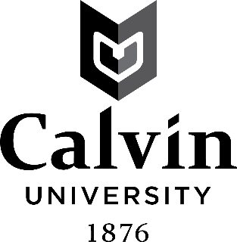
PROFESSIONAL EDUCATION PROGRAM APPLICATION

Date: Student ID: First Name: Last Name:

Email Address: @students.calvin.edu

Which program do you intend to complete?
Elementary Secondary K-12
Major(s): Minor(s):

1. My major and minor programs are accurate in Workday: YES NO
Workday Instructions

2. I have completed EDUC 102 – YES NO IN PROCESS

EDUC 202 – YES NO IN PROCESS

3. GPA: You must have a cumulative GPA of 2.5 or higher as of the day you start EDUC 302-303. If your current GPA is between 2.4 and 2.49, you may appeal to the Education Program Appeals Committee.

4. I have completed a background check through castlebranch.com
(place order - package code an65) YES NO

5. I may be interested in teaching outside of Michigan and have contacted the Teacher Certification Coordinator for advice (email shari.brouwer@calvin.edu ). Specific states/provinces/countries:

6. The Michigan Department of Education requires the following information from all applicants for Michigan Teacher Certification:

1. Have you been convicted of (or pled no contest to) a misdemeanor or felony? YES NO
2. Do you currently have any charges pending? YES NO
3. Have you ever had a teaching, school counselor, school psychologist, school administrator certificate, or other professional license denied, suspended, revoked, surrendered, or nullified? YES NO

If you answered “yes” to any of the above questions, please attach a signed explanation. It is your responsibility to notify the Dean of Education of any misdemeanor or felony charges and convictions while you are a student at Calvin. Failure to disclose any charges or convictions constitutes fraud on this application and could result in dismissal from the Education Program.

“I have provided truthful information on this application.” Enter your initials here:

Return this form to the Education Department or save to your computer and email it to emily.reisler@calvin.edu .

FOR OFFICE USE ONLY: _____MTTC Subject Tests Passed (P or F)
_____EDUC 102 ____________(Date: _________)
_____EDUC 202 ____________(Date: _________)
_____Declared ____________(Date: _________)
_____45 s. hrs. completed Elementary Ed. _____(Date:________)
_____GPA (Date:________)
_____CertifiedBackground.com _____Department Tests Passed: ________________________
_____Release Form
_________Acceptance Letter Date Notes:__________________________________________________________________

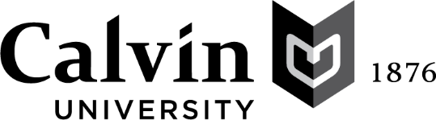

Education Program
Authority to Search and to Release Information

I hereby authorize a representative of the Calvin University Education Program, while I am a student at Calvin University, to obtain any information pertaining to my criminal background history.

I hereby authorize Calvin University to use and release the criminal background history as it sees fit with the understanding that such use or release is done in connection with the Calvin University Education Program.

I understand that such use or release may include, but is not limited to, furnishing this information to third parties, such as the Michigan Department of Education and schools that are considering me for field placement or student teaching internship assignments.

I allow my SAT, ACT and Michigan Test for Teacher Certification scores and course grades to be shared with faculty advisors, School of Education staff, Michigan Department of Education staff, and accreditation auditors as needed.

I release Calvin University from any and all liability for damages of whatever kind which may result from such search of my criminal history and/or the use or release of such information as provided above.

Signature (may be typed) | Date 12/16/2022

Please print or type:

Full Name:
 | First | Middle Initial | Last

Return this form to the Education Office or save to your computer and email to emily.reisler@calvin.edu .

