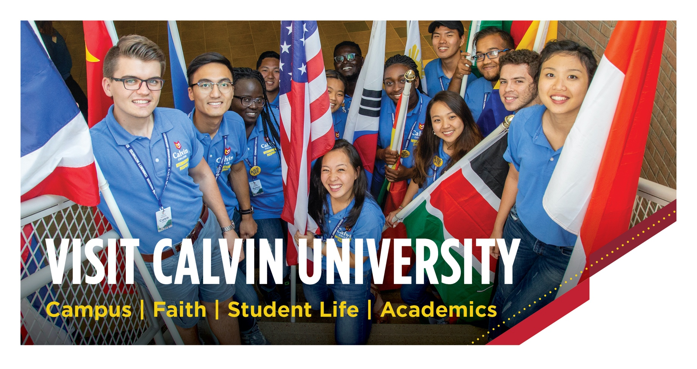2021 International Webinars
Thursdays at 8 a.m. EST
September 30
October 7
October 14
October 21
October 28
November 4
November 11
November 18
Chat with an Admissions Expert
Schedule a virtual meeting with an international admissions counselor.
We'll be happy to answer your questions and discuss
the opportunities for you at Calvin. Go to calvin.edu/visit
